Day 13:
Task 1:
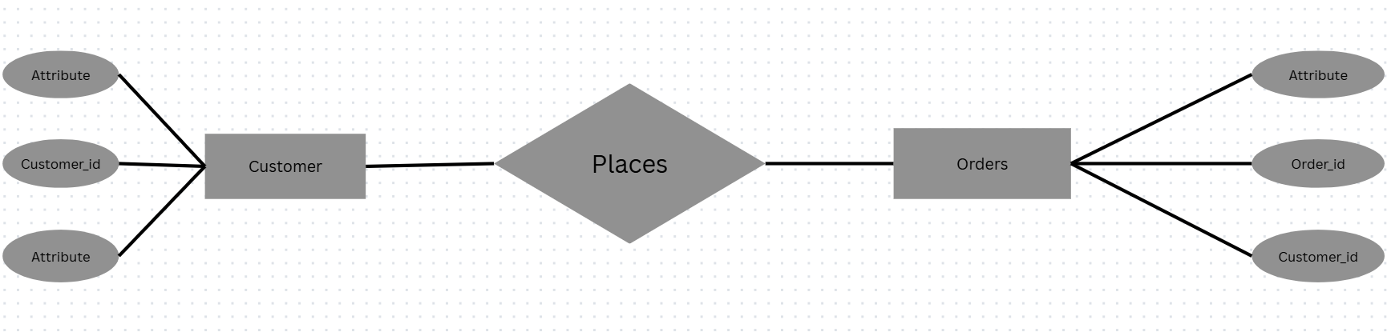
Task 2:
Indexing is a technique used in a Database Management System (DBMS) to improve the speed of data retrieval operations. It creates a separate data structure, called an index, that helps the database find rows quickly without scanning the entire table.
Task 3:
Yes, a good indexing strategy can significantly improve query performance. In fact, indexing is one of the most effective techniques used to optimize database queries.
Task 4:
ACID is a set of properties that ensure database transactions are processed reliably and maintain data integrity, even in cases of system failures, crashes, or concurrent access.
ACID stands for:
- A - Atomicity
- C - Consistency
- I - Isolation
- D – Durability
- Atomicity ensures that a transaction is treated as a single unit of work.
- Either all operations in the transaction are completed successfully.
- Or none of them are executed.
- Consistency ensures that a transaction takes the database from one valid state to another valid state.
- All database rules, constraints, and relationships must remain valid.
- No transaction can violate data integrity rules.
- Isolation ensures that multiple transactions executing simultaneously do not interfere with each other.
Each transaction behaves as if it is running alone.
- Durability ensures that once a transaction is committed, its changes are permanently saved.
Even if:
- Power fails
- System crashes
- Server restarts

Home task:
Task 1:
In PostgreSQL, window functions perform calculations across a set of rows that are related to the current row, while still returning one result per row. Unlike aggregate functions (SUM, COUNT, AVG) that collapse multiple rows into a single row, window functions preserve the individual rows.
Task 2:
- OVER
- PARTITION BY
- ORDER BY
- ROWS
- RANGE
- GROUPS
- BETWEEN
Task 3:
In PostgreSQL, window functions are broadly classified into Ranking Functions (ROW_NUMBER, RANK, DENSE_RANK), Value Functions (LAG, LEAD, FIRST_VALUE, LAST_VALUE), and Aggregate Window Functions (SUM, AVG, COUNT, MIN, MAX used with OVER()).

Task 4:
- Use a window function with OVER().
- Use PARTITION BY to create groups.
- Use ORDER BY to define row order.
- Optionally define a frame using ROWS, RANGE, or GROUPS.
- Window functions do not reduce the number of rows.
- They can be used in SELECT and ORDER BY.
- They cannot be used directly in WHERE, GROUP BY, or HAVING.
Task 5:
JSON | JSONB
Stores data as plain text. | Stores data in a binary format.
Preserves original formatting, whitespace, and key order. | Does not preserve formatting or key order.
Faster for inserts because no conversion is needed. | Slightly slower for inserts due to binary conversion.
Slower for querying and searching. | Faster for querying and searching.
Limited indexing support. | Supports GIN and BTREE indexes for efficient searches.
Duplicate keys are preserved. | Duplicate keys are removed, keeping the last value.

Task 6:
Full-Text Search (FTS) in PostgreSQL is a feature that allows you to efficiently search for words, phrases, and text patterns within large text columns, similar to a search engine.
Task 7:
Full-Text Search in PostgreSQL is a feature that enables fast and intelligent searching of text data by searching for words and phrases instead of matching exact strings.
Task 8:
A SAVEPOINT in PostgreSQL is used to create a checkpoint within a transaction so that you can roll back part of the transaction without rolling back the entire transaction.

